SIMATS ENGINEERING (SAVEETHA SCHOOL OF ENGINEERING)
Department of Computer Science and Engineering
ASSESSMENT TOOL 2 – SCENARIO BASED ASSESSMENT (3 Questions)

Annexure A – Scenario Based Assessment
1. A weather forecasting agency predicts rainfall probability (%) for a week along with uncertainty:

As a data analyst, design a visualization that clearly communicates both probability and uncertainty. Which day’s prediction is most reliable? Justify your answer using visualization principles.
Solution Explanation & Implementation:
• Proposed Visualization Design: Line & Point Chart with 95% Confidence Interval Error Bars and Shaded Uncertainty Bands.
• Forecast Interval Calculations: Mon: 60% ± 10% [CI: 50%–70%]; Tue: 65% ± 20% [CI: 45%–85%]; Wed: 70% ± 5% [CI: 65%–75%]; Thu: 55% ± 15% [CI: 40%–70%]; Fri: 80% ± 25% [CI: 55%–100%].
• Most Reliable Day Determination: Wednesday's prediction (70% ± 5%) is the most reliable.
• Visualization Principles Justification: Wednesday has the smallest confidence interval margin (±5%), reflecting high forecast precision, tight estimation bounds, and minimal uncertainty variance (SE ≈ 2.55%). Although Friday boasts a higher point estimate (80%), its uncertainty interval is extremely wide (±25%, spanning 55% to 100%), reflecting high volatility and unpredictable atmospheric conditions. Thus, Wednesday offers the tightest precision and most reliable forecast for planning.
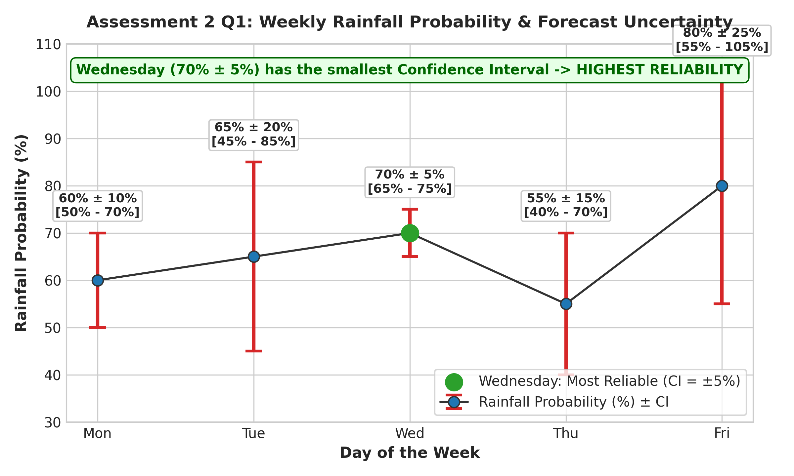
Figure 2.1: Weekly Rainfall Probability Forecast with 95% Confidence Intervals Highlighting Wednesday's Reliability.
2. A mobile app company collects user ratings (1–5) from 500 users. Many users give the same ratings:

If plotted directly, the visualization suffers from overplotting. Propose a suitable visualization technique and explain how transparency or jittering can improve clarity. Suggest an alternative plot if needed.
Solution Explanation & Implementation:
• Overplotting Cause Analysis: Plotting 500 discrete rating responses (integers 1–5: 50, 80, 150, 140, 80) directly on a scatter plot collapses 495 points onto 5 discrete coordinates, rendering sample size and rating density invisible.
• Jittering Technique: Adding uniform pseudo-random horizontal offset U(-0.25, +0.25) spreads overlapping points across rating bands so individual user entries become visually countable.
• Alpha Transparency: Applying point transparency (α = 0.25) allows overlapping points to build up darker color density in high-frequency rating regions (e.g. Rating 3 with n=150).
• Recommended Alternative Plots: A Frequency Bar Chart or Boxplot explicitly quantifies rating counts and distribution medians without point overlap.
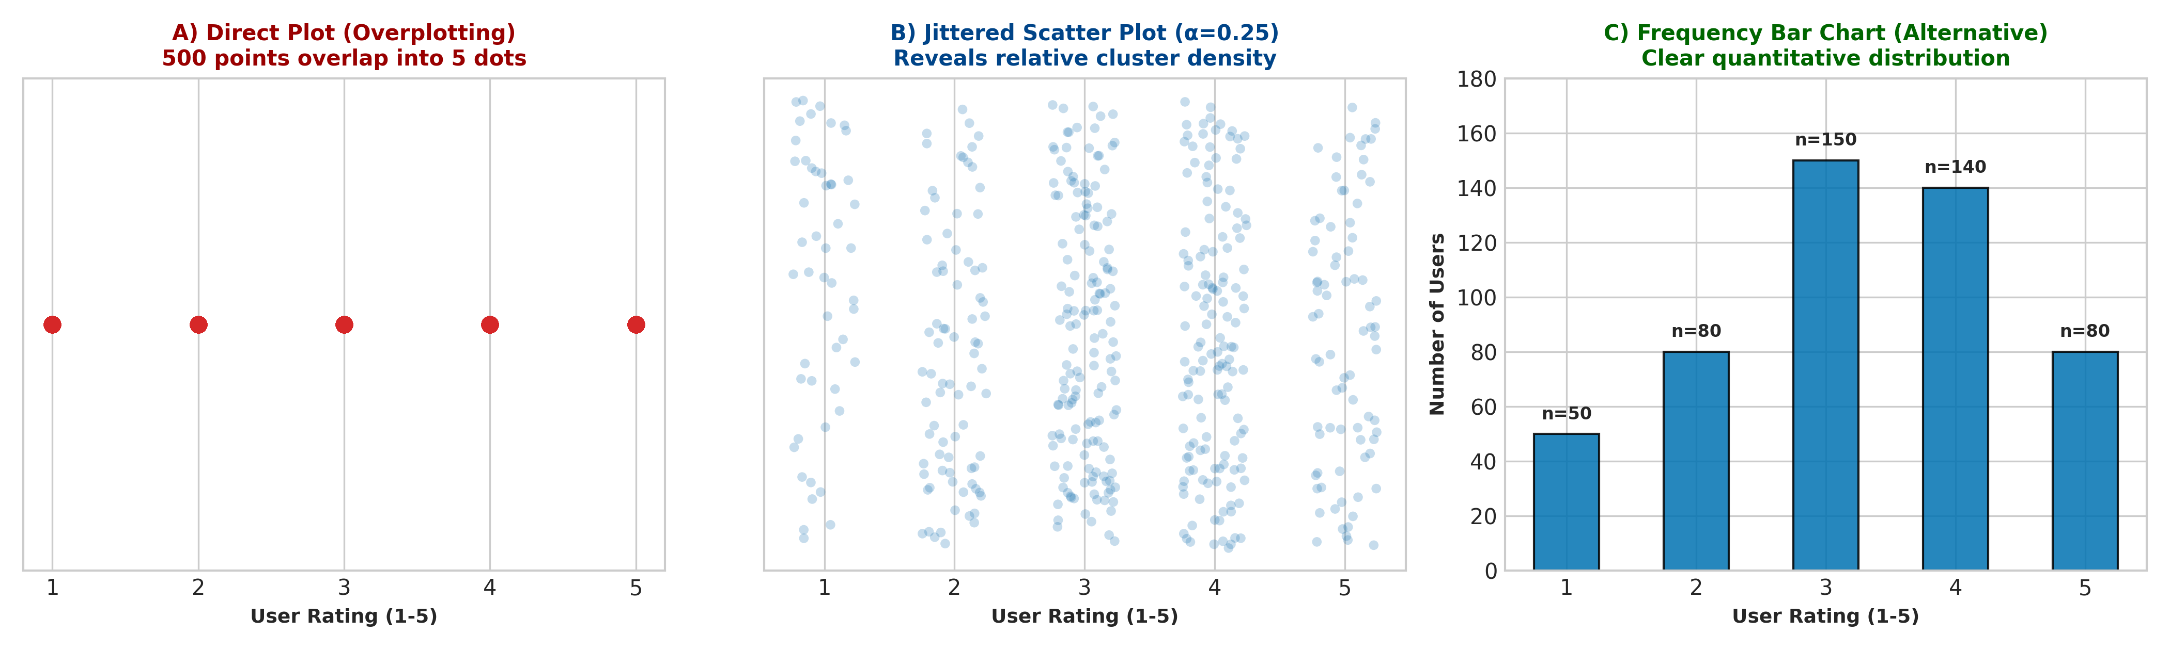
Figure 2.2: Mobile App Ratings Visualized via Direct Scatter (Overplotted), Jittered Scatter with Transparency, and Frequency Bar Chart.
3. A company presents employee satisfaction scores:

The chart uses a truncated y-axis (starting at 65) and red-green color coding.
Identify the issues in this visualization. Redesign it using proper axis design, proportional ink principle, and accessible color choices. Explain how your design avoids misleading interpretation.
Solution Explanation & Implementation:
• Identified Flaws Diagnosis: 1) Truncated Y-Axis (65%–82%): Violates the Proportional Ink Principle. HR (70%) appears to have a bar height of 5 units while Finance (80%) has a height of 15 units (a 300% visual height difference), falsely exaggerating a small 10% numerical gap. 2) Red-Green Color Coding: Inaccessible to colorblind users (Deuteranopia/Protanopia) and introduces misleading moral connotation (framing 70% as a failure/danger in red).
• Redesign Strategy: Enforce a zero baseline (0%–100%) for honest visual proportions. Use a monochromatic colorblind-safe blue palette (#0072B2) and direct numerical data labels.
• Impact on Interpretation: The redesigned chart preserves baseline integrity, presents honest visual proportions between departments, ensures colorblind accessibility, and eliminates artificial visual exaggeration.
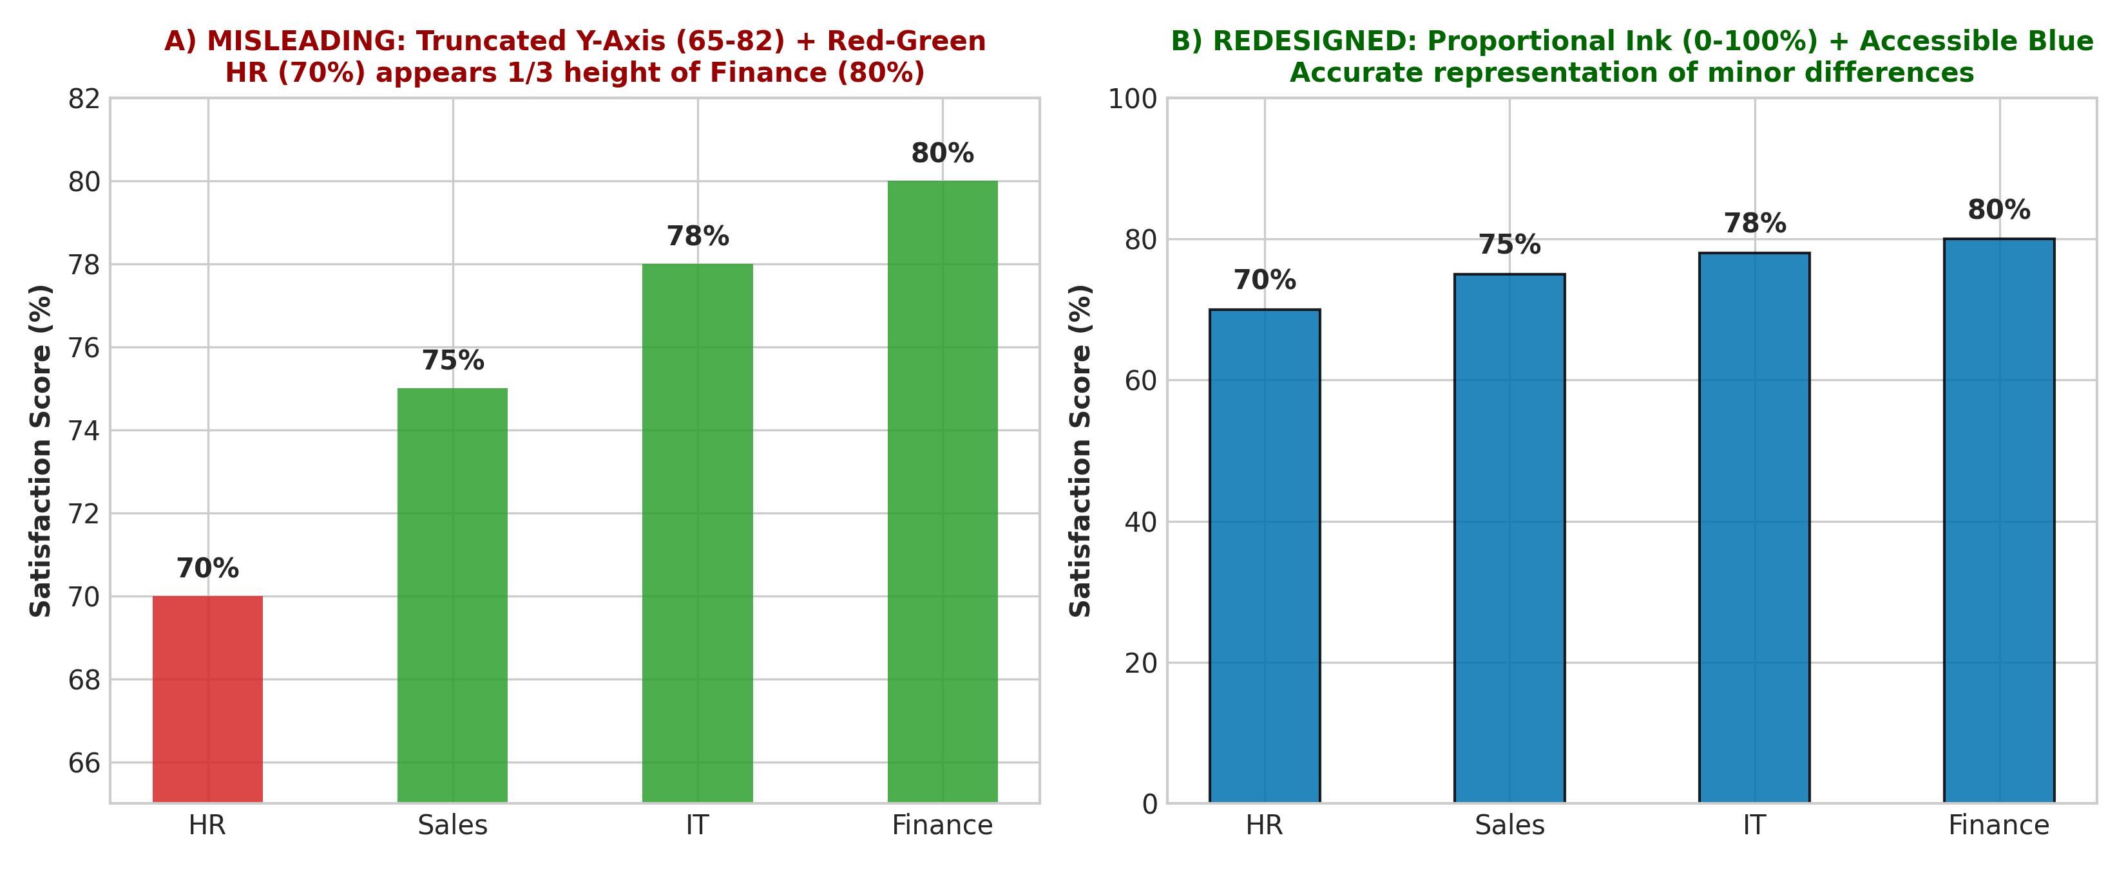
Figure 2.3: Employee Satisfaction Visualization Redesign: Truncated Red-Green Chart vs. Accessible Proportional Ink Chart.
Rubrics for Calculation

Course Code: | DSA06 | Course Title: | Data Handling and Visualization
CO Assessed: | CO5 – Precision (BL6) | Assessment: | Assessment Tool 2 – Scenario Based Assessment
Weightage: | 20% of CIA | Total Marks: | 30 (3 Questions × 10 Marks)
CO5 Statement: | Create effective and interactive visualizations by integrating data wrangling and advanced visualization tools (BL6)
Student Name: |  | Reg. No.:
Section / Batch: |  | Date:
Code of Conduct
I __________________________ (Name / Reg No) certify that this submission is my original work and that I have adhered to the guidelines specified for this assessment. I understand that any violation of academic integrity rules will result in disciplinary action.

Signature of the Student: _________________________
Instructions
- This test contains 3 questions, each carrying 10 marks. Total: 30 Marks.
- No negative marking. Unanswered questions carry zero marks.
- No calculators or electronic devices permitted.
- Duration: 60 minutes.
Section / Topic | Focus Area | Q. Nos. | Marks
Visualizing Uncertainty | Probability visualization, confidence intervals, uncertainty interpretation | 1 | 1
Handling Overplotting | Overplotting, transparency, jittering, alternative plots | 2 | 1
Principles of Effective Visualization & Accessibility | Proportional ink principle, misleading axes, accessible color design | 3 | 1
GRAND TOTAL: |  | 30 Marks
Day | Rainfall Probability | Confidence Interval
Mon | 60 | 10
Tue | 65 | 20
Wed | 70 | 5
Thu | 55 | 15
Fri | 80 | 25
Rating | Frequency
1 | 50
2 | 80
3 | 150
4 | 140
5 | 80
Department | Score (%)
HR | 70
Sales | 75
IT | 78
Finance | 80
Criteria | Weightage (%) | Level 4 (Exemplary) | Level 3 (Proficient) | Level 2 (Developing) | Level 1 (Beginning) | Marks
Understanding of Scenario | 20% | Demonstrates clear and complete understanding of the scenario and context | Shows good understanding with minor gaps | Partial understanding; misses key aspects | Misinterprets or fails to understand the scenario
Identification of Key Issues | 20% | Accurately identifies all relevant issues and factors involved | Identifies most key issues with minor omissions | Identifies limited issues; some irrelevant points | Unable to identify key issues
Application of Concepts | 25% | Applies appropriate concepts effectively to address the scenario | Applies concepts with minor errors | Limited or partially correct application | Unable to apply relevant concepts
Decision Making | 20% | Makes well-reasoned, logical decisions with strong rationale | Makes reasonable decisions with some justification | Makes weak decisions with limited justification | No clear decisions made or rationale provided
Clarity of Response | 15% | Response is clear, structured, and logically presented | Generally clear with minor issues | Somewhat unclear or poorly structured | Disorganized and difficult to understand
Faculty In-charge | Course Coordinator | Head of Department
Signature: _______________ | Signature: _______________ | Signature: _______________
Date: ___________________ | Date: ___________________ | Date: ___________________

